Bayesian Net

M5281054 WANG Binghao

This complete Bayesian network model describes the student's learning status:

1. Node design (7 nodes):

* Difficulty：Easy/Hard
* Intelligence：High/Low
* StudyHours：Many/Few
* Grade：A/B/C
* Tired：Yes/No
* Focus：Good/Poor
* Understanding：Good/Poor

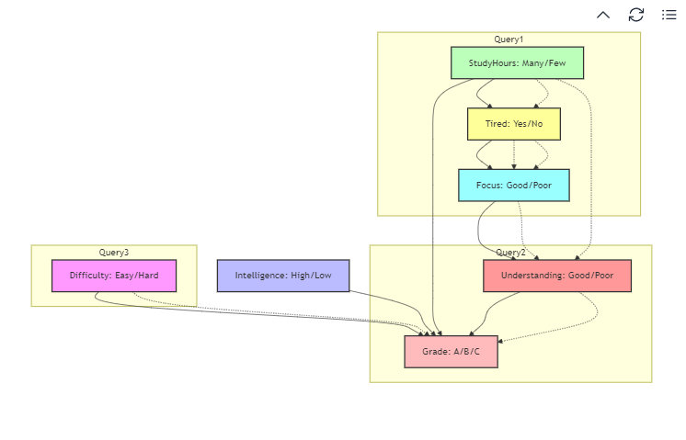

Bayesian network construction diagram

2.Dependencies:

* The exam results (Grade) depend on:
  + Difficulty
  + Intelligence
  + StudyHours
  + Understanding
* Tiredness depends on study hours
* Focus depends on Tiredness
* Understanding depends on focus

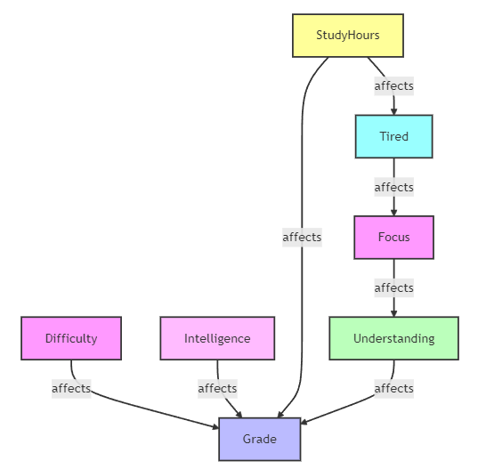

Dependency diagram

Each node in a Bayesian network defines a joint probability distribution

Prior probability (root node):

* The sum must equal 1
* Set reasonable values ​​based on actual conditions

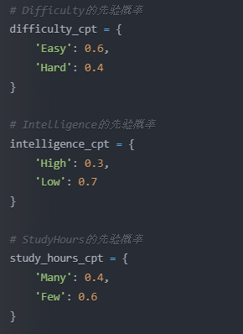

Prior probability of the root node (no parent node)

Conditional probability (with parent node):

* For each combination of parent node states, the sum of the probabilities of the child nodes is 1

• Reflect the actual dependencies between variables

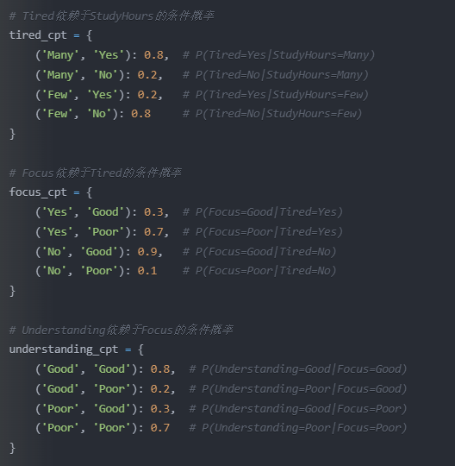

Conditional probability of having a single parent

Processing of multiple parent nodes:

* Need to consider the combination of all parent node states
* The probability distribution of each combination should be reasonable

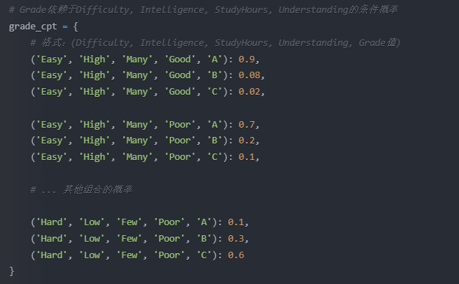

Conditional probability of Grade node (multiple parent nodes)

3. Provide three query examples:

* Query 1: Given learning time and attention state, calculate the probability of fatigue
* Query 2: Given fatigue and understanding, calculate the probability of getting an A
* Query 3: Given the course difficulty and study time, calculate the probability of good understanding

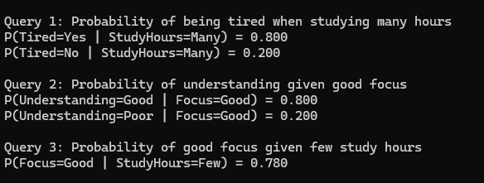

1. Calculation process:

Query 1: P(Tired | StudyHours=Many, Focus=Good)

Calculation Steps:

1. Using Bayes' Theorem:

P(Tired | StudyHours, Focus) = P(Focus | Tired) * P(Tired | StudyHours) * P(StudyHours) / P(Focus, StudyHours)

2. Calculate probabilities for both Tired = Yes and Tired = No:

For Tired = Yes:

P(Focus=Good | Tired=Yes) = 0.3

P(Tired=Yes | StudyHours=Many) = 0.8

P(StudyHours=Many) = 0.4

For Tired = No:

P(Focus=Good | Tired=No) = 0.9

P(Tired=No | StudyHours=Many) = 0.2

P(StudyHours=Many) = 0.4

3. Normalize the results

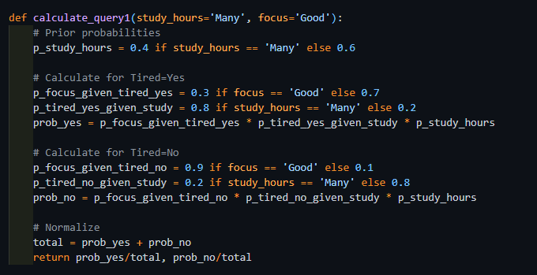

Query 2: P(Grade=A | Tired=Yes, Understanding=Poor)

Calculation Steps:

1. Using Total Probability Formula and Bayes' Theorem:

P(Grade=A | Tired, Understanding) =

Σ(Difficulty, Intelligence, StudyHours) P(Grade=A | Difficulty, Intelligence, StudyHours, Understanding) *

P(Difficulty) * P(Intelligence) * P(StudyHours | Tired)

2. Consider all possible combinations

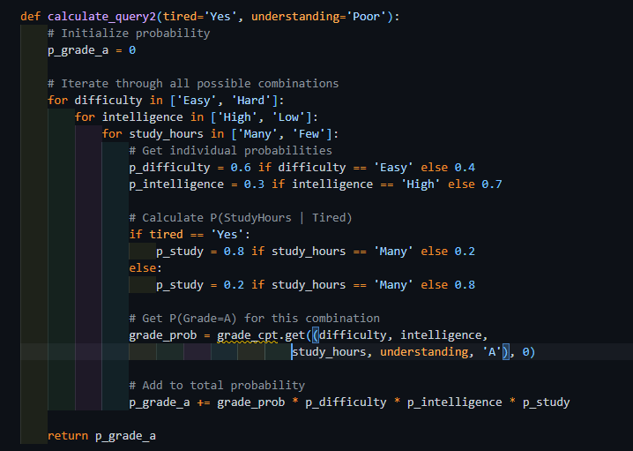

Query 3: P(Understanding=Good | Difficulty=Easy, StudyHours=Many)

Calculation Steps:

1. Using Chain Rule of Conditional Probability:

P(Understanding | Difficulty, StudyHours) =

Σ(Focus) P(Understanding | Focus) * P(Focus | Tired) * P(Tired | StudyHours)

2. Calculate each conditional probability step by step

